Chemistry 115 Name

Dr. Cary Willard

Exam 3a November 6, 2013

Multiple Choice (30 points)

Page 5 (20 points)

Page 6 (20 points)

Page 7 (19 points)

Page 8 (11 points)

Total (100 points)

Percent

All work must be shown to receive credit. Give all answers to the correct number of significant figures

PV=nRT

Avogadros number = 6.022 x 1023 /mol

Ideal gas constant = 0.0821 L atm/mol K

= 62.4 L torr/mol K

1 atm = 760 torr = 760 mm Hg = 101.3 kPa = 14.7 psi

Grossmont College

Periodic Table

|  |  |  |  |  |  |  |  |  |  |  |  |  |  |  |  |  |  |  |
| --- | --- | --- | --- | --- | --- | --- | --- | --- | --- | --- | --- | --- | --- | --- | --- | --- | --- | --- |
| IA |  |  |  |  |  |  |  |  |  |  | |  |  |  |  |  | VIIA | NOBLE GASES |
| 1  **H**  1.008 | IIA |  |  |  |  |  |  |  |  |  | |  | IIIA | IVA | VA | VIA | 1  **H**  1.008 | 2  **He**  4.002 |
| 3  **Li**  6.941 | 4  **Be**  9.012 |  |  |  |  |  |  |  |  |  | |  | 5  **B**  10.81 | 6  **C**  12.01 | 7  **N**  14.01 | 8  **O**  16.00 | 9  **F**  19.00 | 10  **Ne**  20.18 |
| 11  **Na**  23.00 | 12  **Mg**  24.30 | IIIB | IVB | VB | VIB | VIIB | VIII VIII VIII | | | | IB | IIB | 13  **Al**  27.00 | 14  **Si**  28.09 | 15  **P**  30.97 | 16  **S**  32.06 | 17  **Cl**  35.45 | 18  **Ar**  39.95 |
| 19  **K**  39.10 | 20  **Ca**  40.08 | 21  **Sc**  44.96 | 22  **Ti**  47.90 | 23  **V**  50.94 | 24  **Cr**  52.00 | 25  **Mn**  54.94 | 26  **Fe**  55.85 | 27  **Co**  58.93 | 28  **Ni**  58.70 | | 29  **Cu**  63.55 | 30  **Zn**  65.38 | 31  **Ga**  69.72 | 32  **Ge**  72.59 | 33  **As**  74.92 | 34  **Se**  78.96 | 35  **Br**  79.90 | 36  **Kr**  83.80 |
| 37  **Rb**  85.47 | 38  **Sr**  87.62 | 39  **Y**  88.91 | 40  **Zr**  91.22 | 41  **Nb**  92.91 | 42  **Mo**  95.94 | 43  **Tc**  (99) | 44  **Ru**  101.1 | 45  **Rh**  102.9 | 46  **Pd**  106.4 | 47  **Ag**  107.9 | | 48  **Cd**  112.4 | 49  **In**  114.8 | 50  **Sn**  118.7 | 51  **Sb**  121.8 | 52  **Te**  127.6 | 53  **I**  126.9 | 54  **Xe**  131.3 |
| 55  **Cs**  132.9 | 56  **Ba**  137.3 | 57  **La**  138.9 | 72  **Hf**  178.5 | 73  **Ta**  180.9 | 74  **W**  183.9 | 75  **Re**  186.2 | 76  **Os**  190.2 | 77  **Ir**  192.2 | 78  **Pt**  195.1 | 79  **Au**  197.0 | | 80  **Hg**  200.6 | 81  **Tl**  204.4 | 82  **Pb**  207.2 | 83  **Bi**  209.0 | 84  **Po**  (209) | 85  **At**  (210) | 86  **Rn**  (222) |
| 87  **Fr**  (223) | 88  **Ra**  226.0 | 89  **Ac**  227.0 | 104  **Rf**  (261) | 105  **Db**  (262) | 106  **Sg**  (263) | 107  **Bh**  (262) | 108  **Hs**  (265) | 109  **Mt**  (266) | 110  **??**  (269) |  | |  |  |  |  |  |  |  |

|  |  |  |  |  |  |  |  |  |  |  |  |  |  |
| --- | --- | --- | --- | --- | --- | --- | --- | --- | --- | --- | --- | --- | --- |
| 58  **Ce**  140.1 | 59  **Pr**  140.9 | 60  **Nd**  144.2 | 61  **Pm**  (147) | 62  **Sm**  150.4 | 63  **Eu**  152.0 | 64  **Gd**  157.3 | 65  **Tb**  158.9 | 66  **Dy**  162.5 | 67  **Ho**  164.9 | 68  **Er**  167.3 | 69  **Tm**  168.9 | 70  **Yb**  173.0 | 71  **Lu**  175.0 |
| 90  **Th**  232.0 | 91  **Pa**  231.0 | 92  **U**  238.0 | 93  **Np**  (237) | 94  **Pu**  (244) | 95  **Am**  (243) | 96  **Cm**  (247) | 97  **Bk**  (247) | 98  **Cf**  (251) | 99  **Es**  (252) | 100  **Fm**  (257) | 101  **Md**  (258) | 102  **No**  (259) | 103  **Lr**  (260) |

Lanthanide series

Actinide series

Part I – Multiple Choice (30 points)

1. The characteristic bright line spectrum of an element is produced when electron(s)
   1. Move to higher energy levels
   2. Fall back to lower energy levels
   3. Are emitted as gamma radiation
   4. Are absorbed into the nucleus
2. Which does not exist as an electron sublevel?
   1. 3p
   2. 3s
   3. 3d
   4. 3f
3. What is the maximum number of electrons that can occupy the 3d sublevel?
   1. 18
   2. 10
   3. 6
   4. 2
4. How many valence electrons are present in the element with the following ground state electron configuration?

1s2 2s2 2p1

* 1. 3
  2. 1
  3. 2
  4. 4

1. What is the number of valence electrons in an alkaline earth metal?
   1. 1
   2. 12
   3. 2
   4. 7
2. What is the maximum number of electrons that can occupy an orbital?
   1. 1
   2. 4
   3. 2
   4. 3
3. Atoms of the nonmetallic elements generally form ions by
   1. Gaining electrons, forming positive ions
   2. Gaining electrons, forming negative ions
   3. Losing electrons, forming positive ions
   4. Losing electrons, forming negative ions
4. Which atom has the largest radius?
   1. O
   2. S
   3. Se
   4. Te
5. The number of electrons in a triple covalent bond is
   1. 8
   2. 2
   3. 3
   4. 6
6. If the size of the fluorine atom is compared to the size of the fluorine ion.
   1. They would both be the same size
   2. The atom is larger than the ion
   3. The ion is larger than the atom
   4. The size difference depends on the reaction
7. Which of the following characterizes covalent bonding?
   1. The formation of true, discrete molecules
   2. The formation of ions
   3. The type of bond normally found between metals and nonmetals
   4. The loss of electrons
8. The volume of a gas must always increase when
   1. Temperature decreases and pressure increases
   2. Temperature decreases and pressure decreases
   3. Temperature increases and pressure increases
   4. Temperature increases and pressure decreases
9. Which of the following has a volume that consists of mostly empty space?
   1. F2(g)
   2. I2(s)
   3. Br2(l)
   4. Na(s)
10. As the temperature of a sample of gas is increased at constant pressure, its volume will
    1. Increase
    2. Decrease
    3. Remain the same
11. A mixture of gases consists of helium at a partial pressure of 400. torr, neon at a partial pressure of 300. torr, and argon at a partial pressure of 200. torr. What is the total pressure of this mixture of gases?
    1. 300. torr
    2. 760. torr
    3. 900. torr
    4. 1000 torr

Part 2 – Problems and Short Answer (70 points)

1. (4 points) Write the complete electron configuration for an atom of silicon. How many valence electrons does silicon have?
2. (4 points) Write the shorthand electron configuration for an atom of iodine (I).
3. (4 points) If a p sublevel has 5 electrons, which orbitals will they occupy? Draw the sublevel using arrows to represent electrons and show spin based on the direction of the arrow in the orbital diagram below.
$$\underset{p sublevel}{\underbrace{\boxed{} \boxed{} \boxed{}}}$$

4. (4 points) Define the term ionization energy. Show how the ionization energy changes as you move across and down the periodic table using arrows.

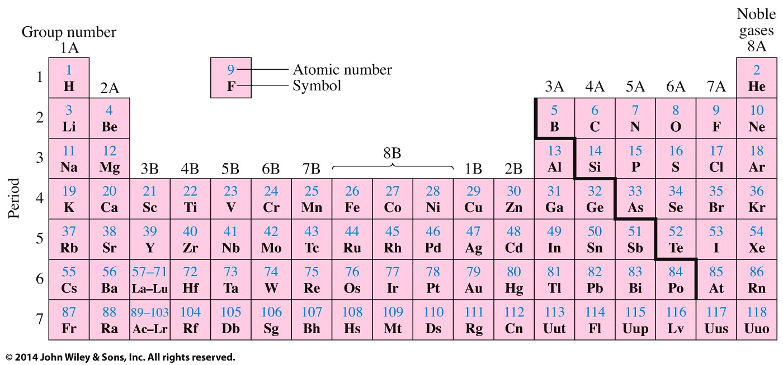

1. (4 points) Explain how an ionic bond differs from a covalent bond.
2. (10 points) Draw Lewis Electron Dot Structures for the following atoms/molecules.
   1. O
   2. SCl2 (Sulfur is the central atom)
   3. N2H2 (H∙∙∙N∙∙∙N∙∙∙H is the skeleton structure.)
3. (10 points) Predict the orbital or molecular geometry of the indicated atoms:

Molecular geometry Ca



Orbital geometry Cb

Molecular geometry Nc

Orbital geometry Pd

Molecular geometry Pd

1. (6 points) Draw Lewis Electron Dot Structures for the nitrite ion (NO2−). Include reasonable resonance structures. (nitrogen is the central atom)
2. (8 points) A 35.0 L flask is filled with 381 g of oxygen gas (O2) at a temperature of 27oC.
   1. How many moles of oxygen are contained in the flask?
   2. What is the pressure (in atm) of oxygen gas in the flask?
   3. What is the pressure in lb/in2(psi) of oxygen gas in the flask?
3. (5 points) Ammonia gas is produced by the reaction of nitrogen gas and hydrogen gas as shown in the equation below:

N2 (g) + 3 H2(g) 🡪 2 NH3(g)

How many L of ammonia can be produced by the reaction of 4.92 L of hydrogen gas with excess nitrogen gas if the pressure and temperature are held constant?

1. (6 points) You are responsible for ensuring that the giant American eagle balloon stays inflated at the local Veteran’s day parade. You inflate the balloon to a pressure of 976 torr using 5.17 x 105 mol of helium in the morning when the temperature is 12oC. At the end of the day the temperature increases to 31oC and 15% of the helium seeps out of the balloon.
   1. How many moles of air will be left in the balloon at the end of the day after 15% is lost?
   2. What will the pressure of the balloon be at the end of the day if the volume is unchanged?
2. (5 points) What is the molar mass of an unknown gas that has a density of 23.8 g/L, a pressure of 5.36 atm and a temperature of 75oC?